**Assignment 8.6**

**Problem Statement:**

1. How can you check the status of a job submitted in hortonworks cluster?

2. Open the HDFS web UI in hortonworks cluster and browse the file system.

3. How can you check the log files of a job in hortonworks cluster?

**Problem1: How can you check the status of a job submitted in hortonworks cluster?**

**Solution:**

Similar to the information available from the Resource Manager UI about MapReduce Jobs, it is possible to obtain details on Running and Finished MapReduce Jobs on the command line. Information such as the number of maps and reduces, various counters and resource usage by the job can be collected using the "mapred" command line tool.  
Follow the steps given below for "FINISHED" MapReduce Jobs:

Obtain the specific application ID and job ID by running the following command as "yarn" user:

# yarn application -list -appStates FINISHED   
An example output is as follows:  
application_1448259330136_0016    select count(*) from hdfsa...dt>"2015-11-23"(Stage-1)    MAPREDUCE    ratish    hiveq    FINISHED    SUCCEEDED    100% http://rm-testnode1.novalocal:19888/jobhistory/job/job_1448259330136_0016

Use the job ID from the URL in the previous command output to check the job details:

# mapred job -status <Job_ID>

And for Jobs that are "RUNNING", follow the below steps to find the job details:

Find the application ID from the list of RUNNING applications:

Login as "yarn" user, and run the command:   
# yarn application -list -appStates RUNNING  
An example output is as follows:  
application_1450309877692_0007              word count               MAPREDUCE     ambari-qa       default               RUNNING             UNDEFINED                50%      http://rm-testnode1.novalocal:57521

Get the corresponding job ID from mapred command:

# mapred job -list all | grep <Application ID>

Use the Job ID from step #2 to get the job details:

# mapred job -status <Job_ID>

**Problem 2: Open the HDFS web UI in hortonworks cluster and browse the file system.**

**Solution:**

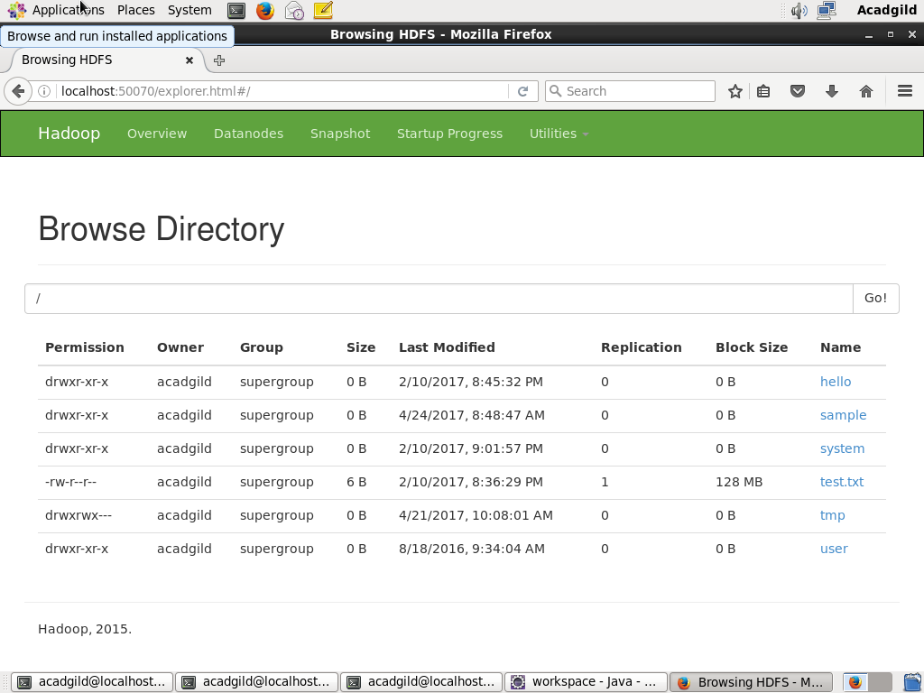

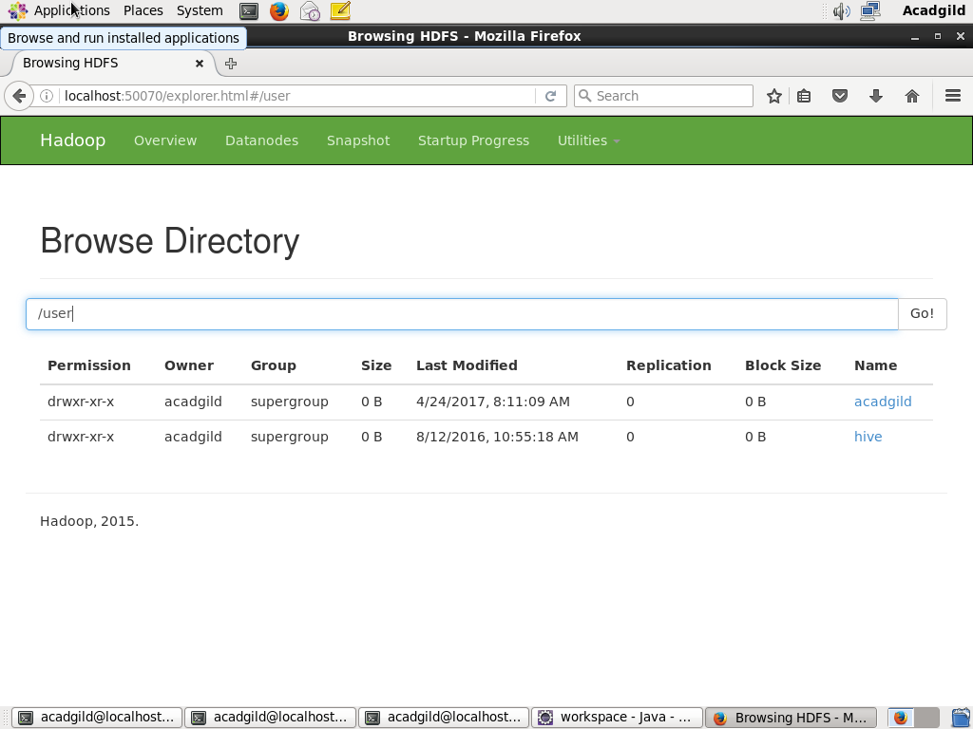

**Problem 3: How can you check the log files of a job in hortonworks cluster?**

**Solution:**

